RESOLUTION NO.__________

RE: CERTIFICATE OF APPROPRIATENESS UNDER THE
PROVISIONS OF THE ACT OF THE PENNSYLVANIA
LEGISLATURE 1961, JUNE 13, P.L. 282 (53
SECTION 8004) AND BETHLEHEM ORDINANCE NO.
3952 AS AMENDED.

The applicant proposes to install a marque sign on the Hotel Bethlehem Ice Cream Parlor at 462 Main St.

NOW, THEREFORE, BE IT RESOLVED by the Council of the City of Bethlehem that a Certificate of Appropriateness is hereby granted for the proposal.

Sponsored by: (s)

(s)

ADOPTED BY COUNCIL THIS DAY OF

(s)
President of Council

ATTEST:

(s)
City Clerk

HISTORICAL & ARCHITECTURAL REVIEW BOARD

The applicant proposes to install a marquee sign on the Hotel
Bethlehem Ice Cream Parlor at 462 Main St.

APPLICATION #4a:
Walk In

Peter Kozicky
462 Main St.
Bethlehem, PA 18018

OWNER:

__________________________________________________________________________

The Board upon motion by Marsha Fritz and seconded by Connie Glagola adopted the proposal that City Council issue a Certificate of Appropriateness for the following:

- Marque sign on the sides of 462 entrance with off-white background.

2. Historic Bethlehem part in brick red and ice cream in black.

3. Black line to go between the top and bottom of the sign.

4. The motion was unanimously approved.

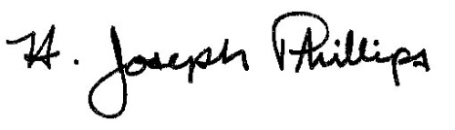 By:__H. Joseph Phillips___________

Title: __Historic Officer____________

Date of Meeting: October 3, 2018

